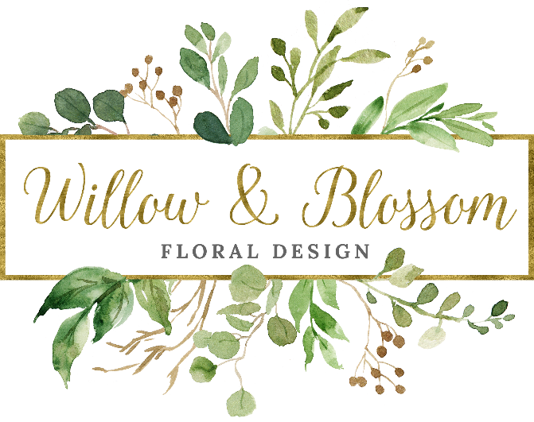
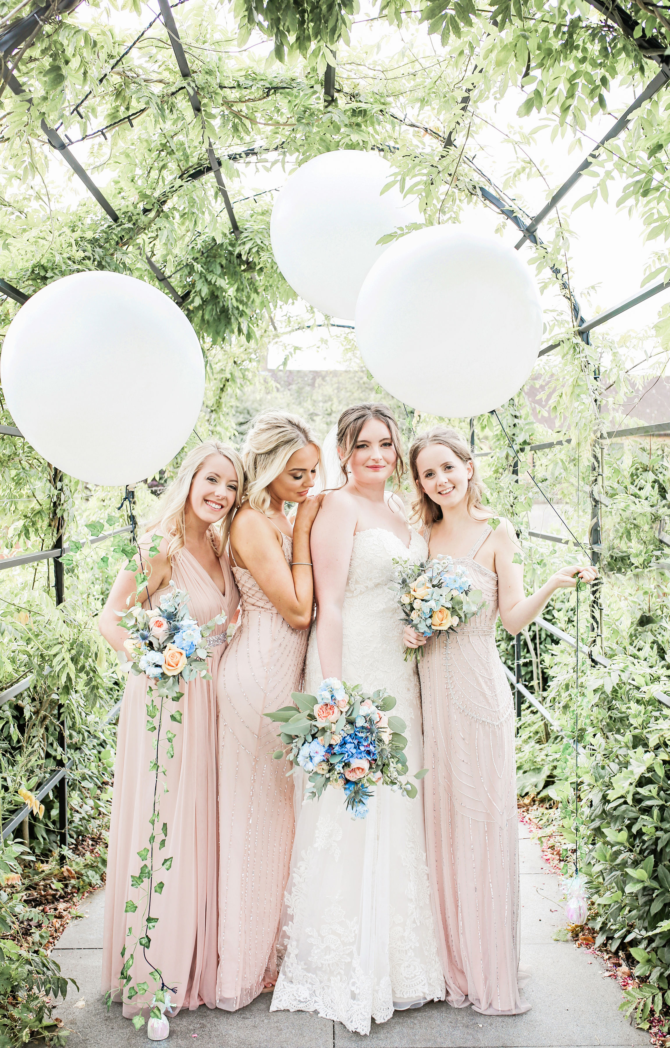
Wedding Guide

Thank you for considering us for your wedding flowers.

Willow & Blossom specialise in creating bespoke wedding flowers to suit the theme & feel of your wedding day. We particularly love creating textured, natural, romantic designs.

At an initial free consultation, we will discuss your requirements for the big day. We will look at colours, flower choices, design ideas etc to make sure we are creating your dream flowers. After your consultation you will be emailed your quote within a week. If you are unable to attend a consultation in person and would like an email consultation please do let me know.

If you wish to proceed with the booking I ask for a non-refundable deposit of £150 of the total balance to secure your wedding date. I will then contact you again a couple of months before your wedding to finalise all the details.

Each wedding is bespoke so providing a price guide can be difficult. Prices will depend on several things such as, seasonal availability of flowers, size, of design complexity of design etc. I appreciate it is helpful to have a rough idea of costs to help you budget for your flowers so I have included a rough price guide below. Your personal quote will confirm prices relating to your specific requirements.
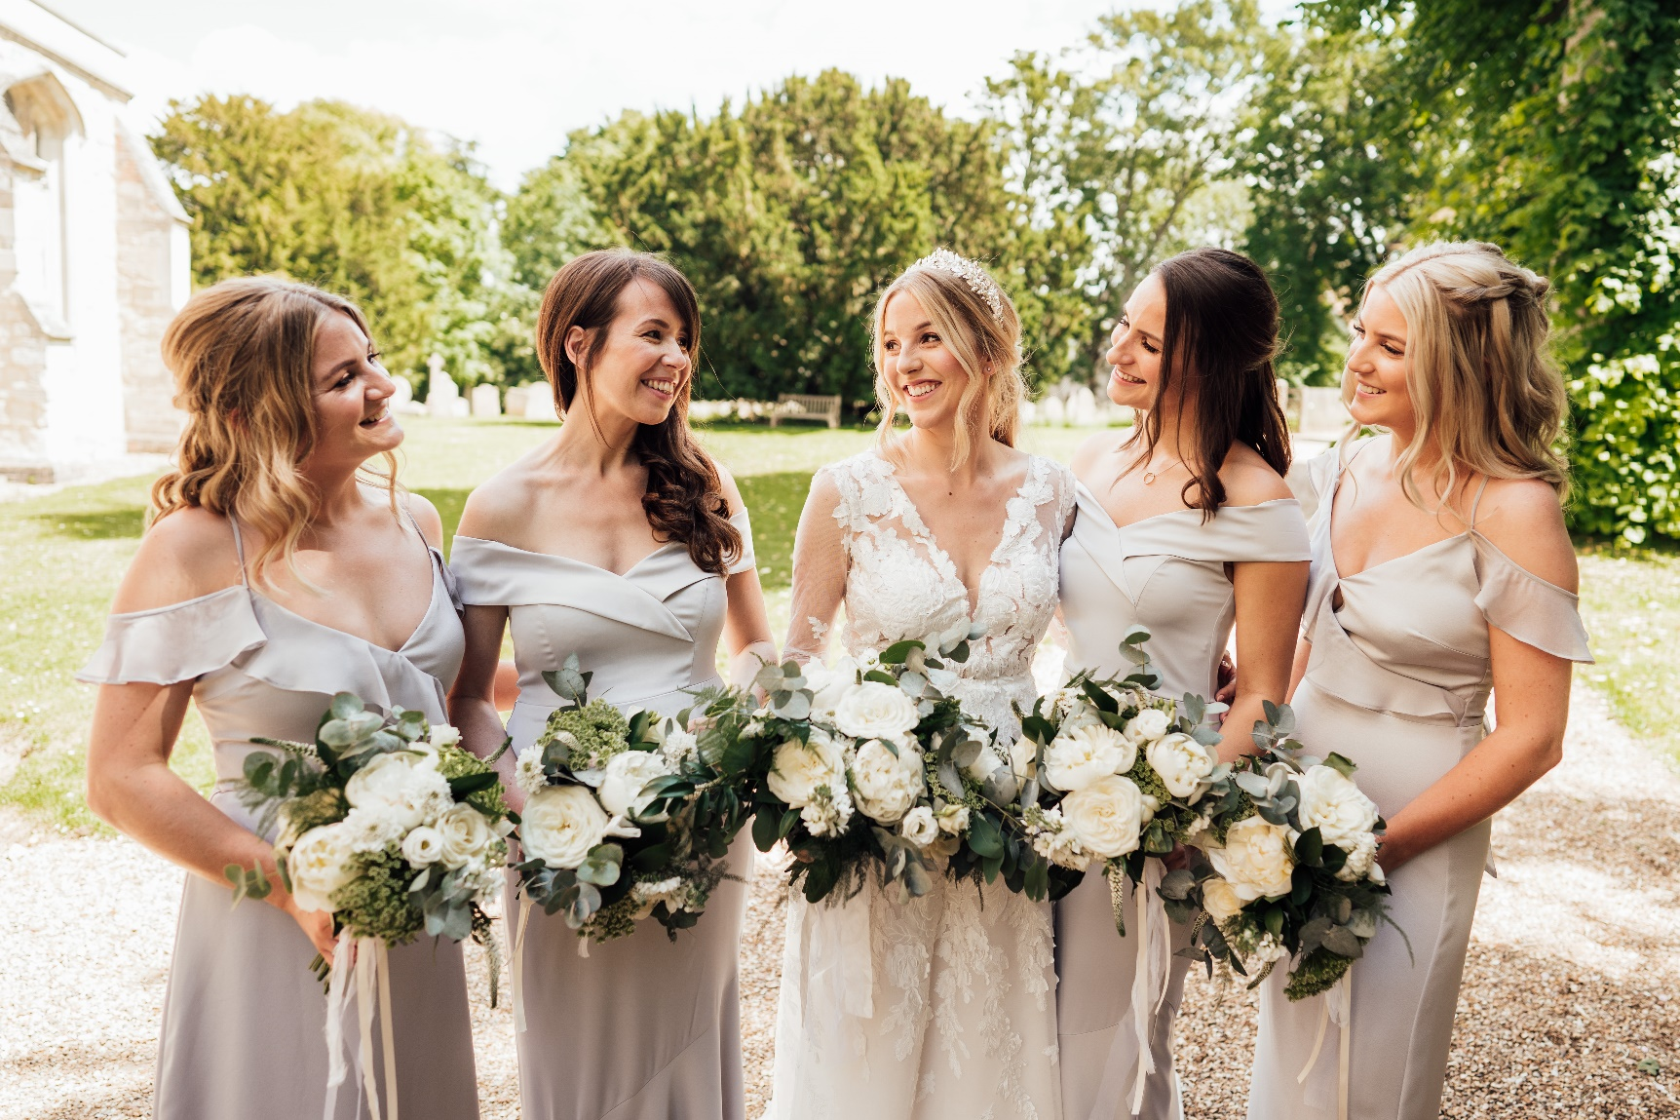
Prior to your consultation it is helpful for us to have some information about your day so we can research possible design ideas. Please fill in the below questionnaire and forward it to us at info@willowandblossomfloral.co.uk

I look forward to hearing from you, Ellice x
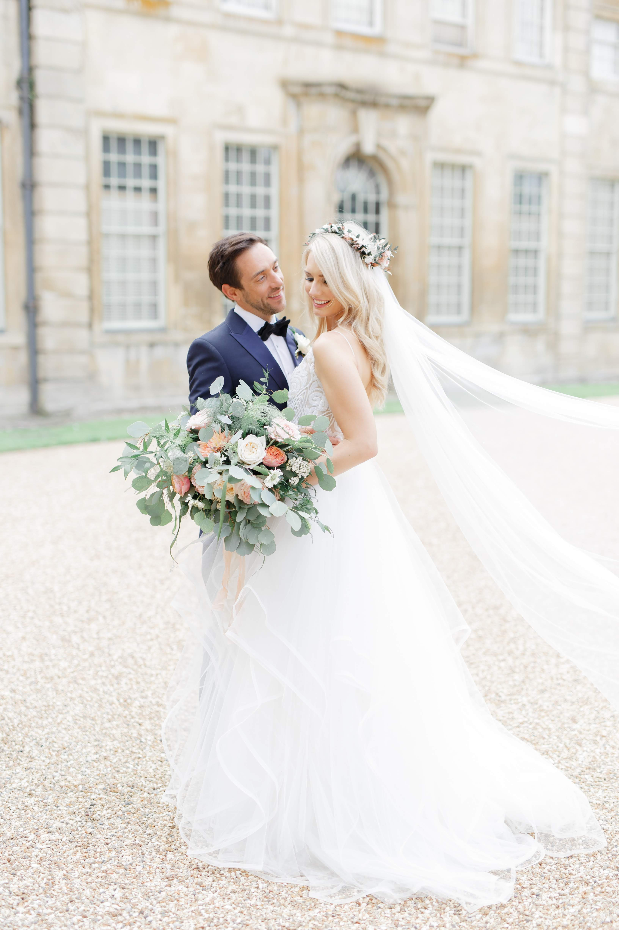
Price Guide
Bridal Handtied Bouquet from £75
Natural/Informal Bridal Bouquet from £95
Bridal Shower Bouquet from £95
Bridesmaid Bouquet from £45
Child Bridesmaid Bouquet from £25
Wrist Corsage from £25
Buttonholes from £6
Long & Low Arrangement from £80
Low Table Centres from £35
Tall Table Centre Arrangement from £70
Jam Jar Arrangement from £8
Cake Flowers from £20
Urn/Pedestal Arrangement from £90
Foliage Garland £15 per foot
Large Installations from £150

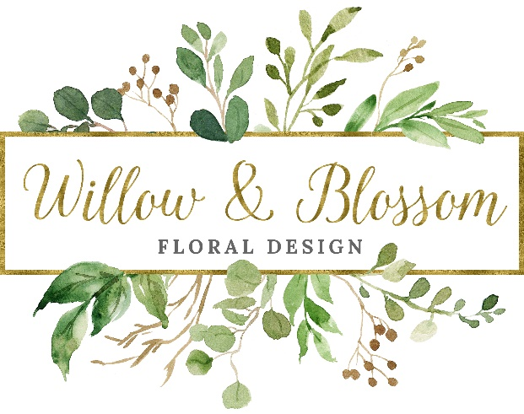

PRE WEDDING QUESTIONNAIRE
Date of Wedding:

Ceremony Time:

Ceremony Venue:

Reception Time:

Reception venue:

Couple Details –
Names
Address
Phone
Email
What look / feel / style / element would you like your wedding to convey?
Number of Bridesmaids & colour of dresses

Number of groomsmen, Best Man etc & suit colours

Number of Flower Girls/Page Boys
Photographer details:

Favourite Flowers
Flower Budget – state estimated amount

Please tell us about yourself and your wedding plans.

Ceremony decoration, please state number required
Pew Ends/ Chair Flowers:
Registrar table arrangement:
Arch:
Entrance arrangement:
Pedestal arrangements:
Reception Decoration, please state number required
Top Table arrangement:
Guest table arrangements:
Cake Flowers:
Other:
Estimated number of guests:
Number of guest tables:
Finally, where did you hear about us? :

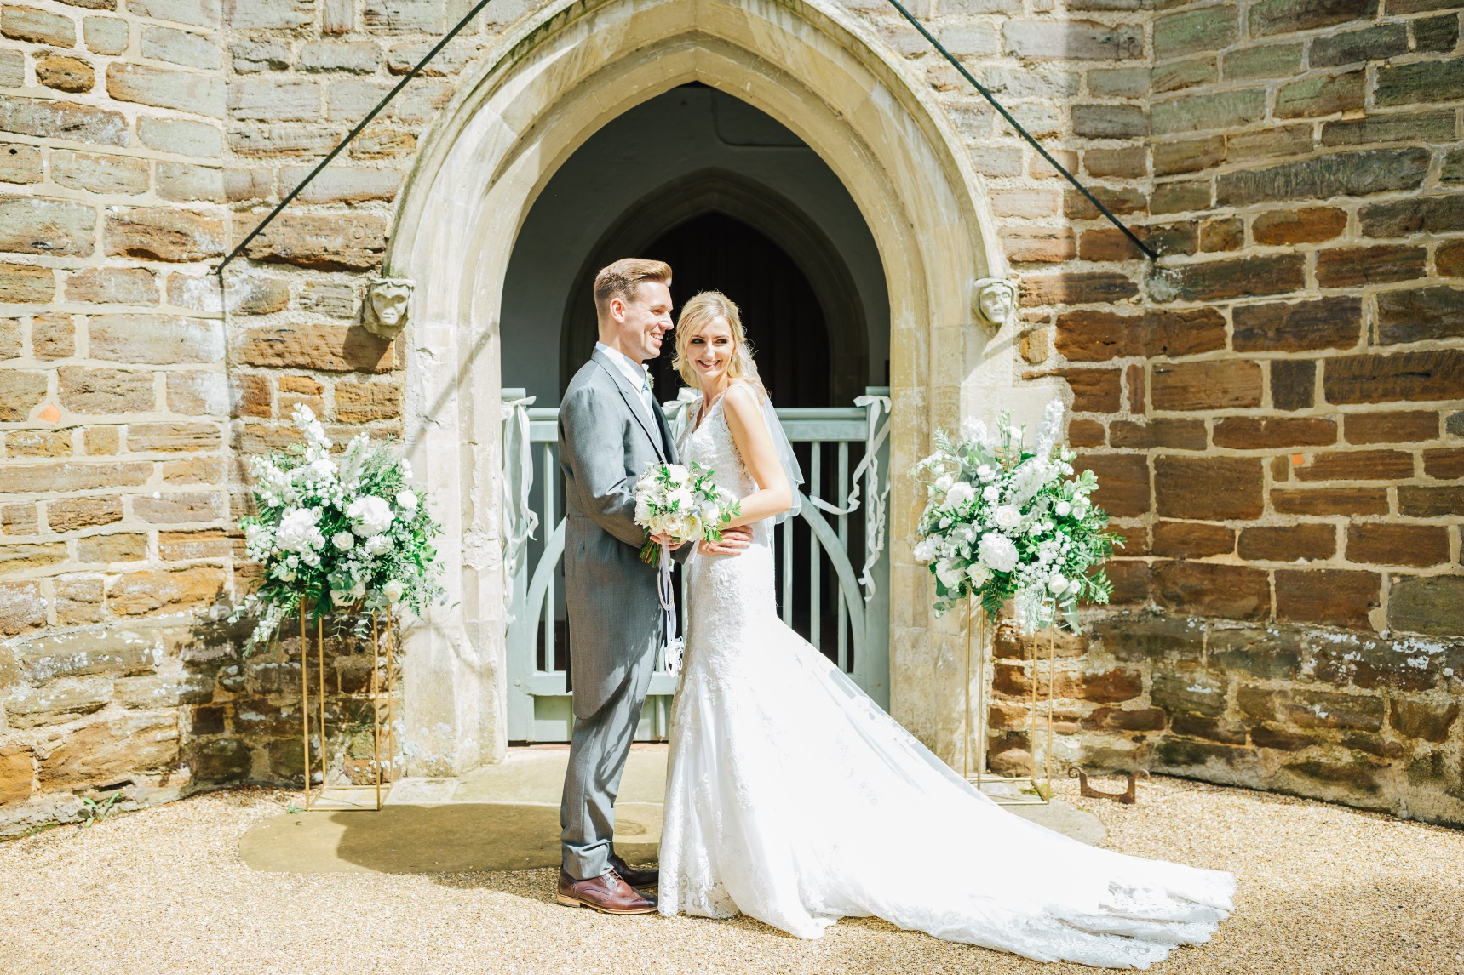
Please complete this form and return to info@willowandblossomfloral.co.uk Please also include any flower inspiration photos or a link to your pinterest board. Thank you x

